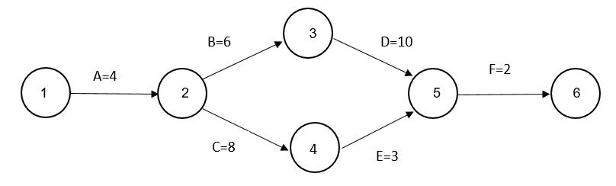

1. Identify all paths and their duration?
2. Identify the critical Paths?
3. Identify the burst nodes and merge nodes?
4. Calculate ES,EF, LS,LF for each node using both forward and backward passes?

**The answer of question :**

**1)**

**Path 1 -🡪 A,B,D,F**

**Path 2 🡪 A,C,E,F**

**2)**

**The Critical path is : Path 1**

**3)**

**Burst = 2 , merge = 5**

**4)**

**Node 1 : ES=0 EF=4**

**LS=0 LF=4**

**Node 2 : ES=4 EF=10**

**LS=4 LF=10**

**Node 3 : ES=10 EF=20**

**LS=10 LF=20**

**Node 4 : ES=20 EF=22**

**LS=20 LF=22**